- Check if Git client is installed properly:
git –version
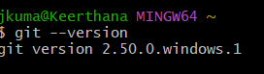

- Check if the configuration is properly set
git config –global --list
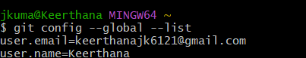

- Integrate notepad++.exe to Git and make it a default editor
notepad++

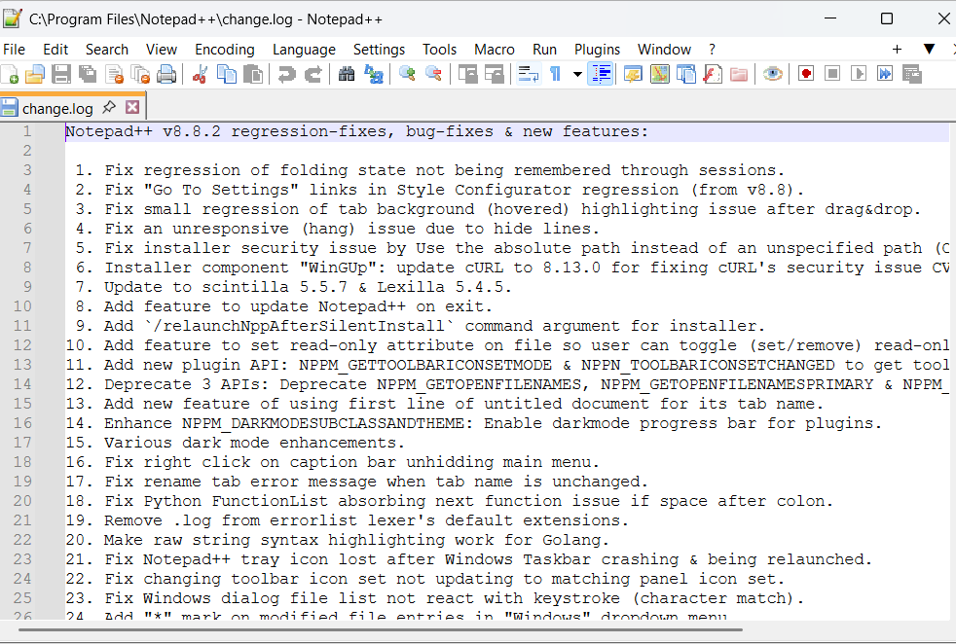

- Configure the editor
git config –global core.editor “’D:/Notepad++/notepad++.exe’ -multiInst -nosession -noPlugin”

- Verify git’s editor setting
git config –global --edit
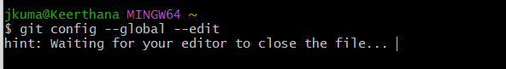
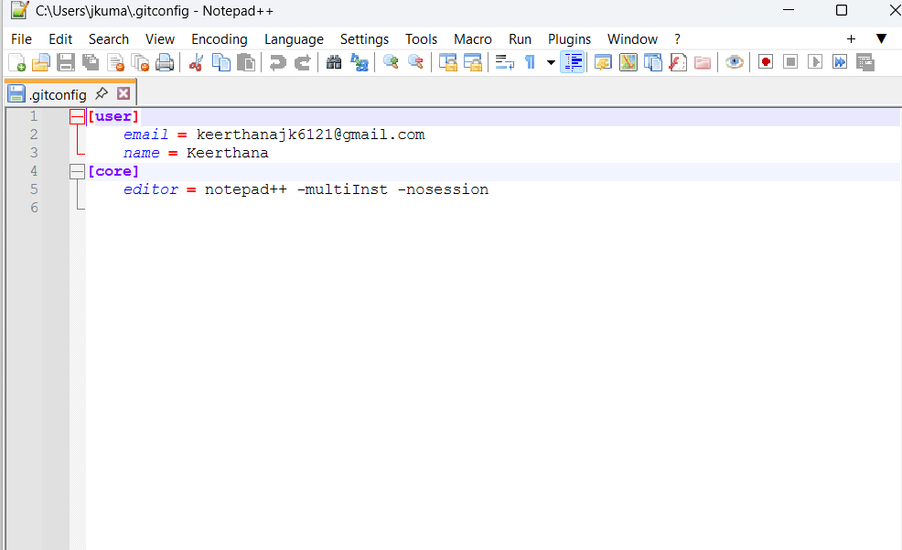

- Create folder and initialize git repo
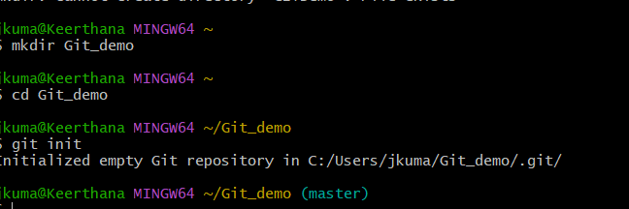

- Verify .git folder exists
ls -al
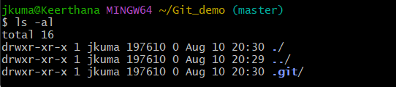

- Create the file welcome.txt with content
- Verify if the file “welcome.txt” is created
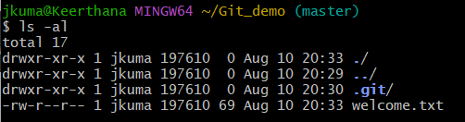
- Verify contents of welcome.txt
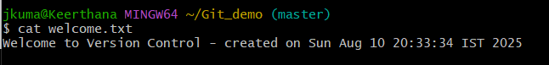

- See repository status
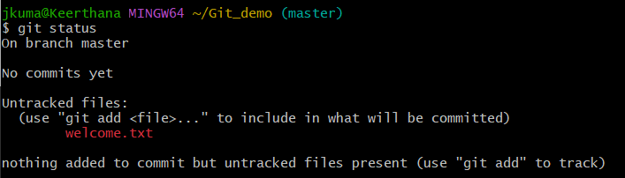

- Start tracking the file
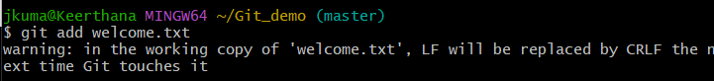

- Add multi-line commit message using default editor
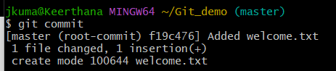

- Check if local and “Working Directory” git repository are same
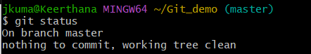

- Connect to GitLab repo
- Pull the remote repository
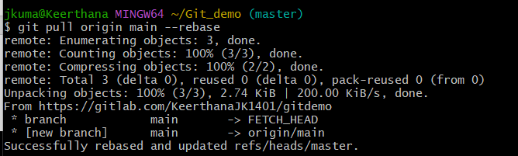
- Push the local to remote repository
